Flood Monitoring and Early Warning System Using

Ultrasonic Sensor

**Abstract**.

The purpose of this study is to develop a real-time flood monitoring and early warning

system in the northern portion of the province of Isabela, particularly the municipalities near

Cagayan River. Ultrasonic sensing techniques have become mature and are widely used in the

various fields of engineering and basic science. One of advantage of ultrasonic sensing is its

outstanding capability to probe inside objective non-destructively because ultrasound can

propagate through any kinds of media including solids, liquids and gases. This study focuses

only on the water level detection and early warning system (via website and/or SMS) that alerts

concern agencies and individuals for a potential flood event. Furthermore, inquiry system is also

included in this study to become more interactive wherein individuals in the community could

inquire the actual water level and status of the desired area or location affected by flood thru

SMS keyword. The study aims in helping citizens to be prepared and knowledgeable whenever

there is a flood. The novelty of this work falls under the utilization of the Arduino, ultrasonic

sensors, GSM module, web-monitoring and SMS early warning system in helping stakeholders

to mitigate casualties related to flood. The paper envisions helping flood-prone areas which are

common in the Philippines particularly to the local communities in the province. Indeed, it is

relevant and important as per needs for safety and welfare of the community.

1. Introduction:

In most countries in the world, flood had caused damages to properties and it involved a large amount

of loss to individuals and governments. During flood, it is important to have efficient flood response

operation system to manage all activities among different related agencies.

These last decades, lots of flooding risk technologies has been developed to minimize the danger of

flood in inhabited areas. Currently, the Philippine government funded the Project NOAH of the

Department of Science and Technology (DOST). They installed Automated Rain Gauges (ARG) and

Water Level Monitoring Stations (WLMS) along the country’s major river basins (RBs) [1]. However,

project NOAH is still under development in which some essential information are not yet available to

view in their website.

Most of these technologies being developed commonly apply in weather forecasting, flood detection

and monitoring system using sensing devices, modeling software, Internet and mobile technology [2].

However, these systems are usually for one-way communication only. In order to get an update or latest

information, local communities need to access the website. And in accessing this website, it requirescomputer or smart phone that has an Internet feature, and most individual could hardly afford to purchase

one. In addition to that, individuals are busy for their daily routine, and monitoring activity cannot be

their priority [1]. These are the reasons why communities are blinded with the current status of the

nearby river watershed. The unawareness led to the overflow of the watercourses of the river waterway

and the subsequent inundation of various localities causing extensive damages to properties and human

life.

The City of Ilagan is located at the central portion in the province of Isabela. It is the River Basin of

its neighboring towns particularly in the southern portion of the province. Floods caused by these rivers

flow down very slowly because of surface retention over the extensive flood plain, extremely gentle

slope, retardation of flood by several gorges and river meander [3].

This paper presents a project that is more localized to help the communities affected by flood in the

province of Isabela particularly in the northern area by providing an interactive and real-time

information on the current water level in the two majors portion of the province. This project also widens

the coverage of people that can receive the information to improve the emergency measures during

floods.

Furthermore, this study builds a prototype that detects the current water level across the watershed

of Cagayan River and its surrounding areas through ultrasonic sensors. The geographical area was subdivided

into two, where monitoring devices were installed. Specifically, the objectives of this study isto create a flood monitoring system that monitor the water level of the rivers using ultrasonic sensors

and to design and develop an early warning system.

2. Architectural Framework

The two monitoring devices are composed of Ultrasonic sensor to measure the distance of the water

level, Arduino micro-controller that process the signal from the sensor, GSM module to send the data

or information from the micro-controller to the computer server and a power source using Solar Panel,

Regulator and Battery. Once a sensor is triggered, an output signal will be relayed to the micro-controller

which serves as a switch that triggers the connected GSM module to send an alert message or water

level status to another GSM modem connected to a computer server. Then, the developed program

installed in the computer server will interpret and analyze the message received then automatically send

a text message to the concern agencies’ numbers stored in a database. Also, the developed program will

then automatically relay the alert message or status by uploading to the developed website. Furthermore,

concern agencies, local officials and the local communities could inquire about the current status by

sending a message that contains keywords.

This paper presents the utilization of ultrasonic sensors because of its capability and reliability. Since

the Philippines is considered among the most flood prone in the world due to variety of factors, the

project NOAH relies on Ultrasonic sensors for water level monitoring. Ultrasonic sensors are deployed

on hundreds of coastal tide gauge platforms that provide tsunami and tropical storm surge warning data.

They are also deployed on similar platforms that monitor flooding on the different rivers. The newest

flood warning system is being deployed to monitor flooding on urban street. And with continues

development in ultrasonic sensing, the researchers opted to use this sensor for the project.

The use of GSM also presented in this paper for transmitting data and as mode of communication to

the concern stakeholders of this project. Due to its simplicity and availability to the public now-a-days,

it is very obvious that information dissemination can be easily achieved. Specifically, the study utilizes

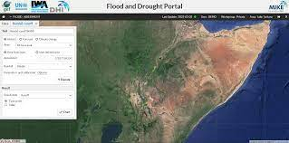

the use of SMS for the reason that aside for being the cheapest way to avail and transmit information in

a remote area, it doesn’t require high data bandwidth.

**3. Methodology**

The ultimate aim is to build a water level detection using ultrasonic sensor to monitor the rivers in the

south-east and south-west portion of the province of Isabela and develop a web and SMS application as

an early warning system that provides essential information to the local communities and concern

agencies.

An SMS approach was used for transmitting data from the monitoring system to the computer server

and for sending notification to the concern stakeholders. The SMS application was installed in the

computer server to process the received data and make proper action. The application also implement

fuzzy logic algorithm for decision making. The inputs of the algorithm are the water level status coming

from the two monitoring systems sent through SMS. A threshold value was set in the two monitoring

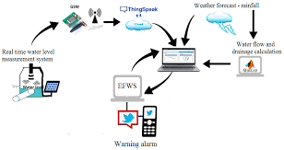

system as basis for the Arduino to trigger the GSM module to send an SMS to the computer server.

Then the developed program installed in the computer server send an SMS notification to the concern

stakeholders and uploads an update post in the developed web-based monitoring system. After the

development of the prototype, the model had undergone several tests and experimentations to check the

effectiveness of the system.

4. Result and Discussion

**4.1 Flood monitoring system that monitors the water level of the rivers using ultrasonic sensor**

The researchers played out a model, test the ease of use and dependability of the developed prototype.

It was tried first in a prototype environment that the researchers made and played out the trial. The test

decided whether it meets the necessities of the client.

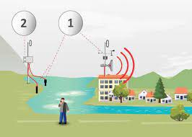

**4.2 Prototype Monitoring System Testing**

The researchers tested the developed prototype through a temporary basin to test the level of water. The

inputs have several sub-parameters to obtain accurate data. In the designed prototype, water level is

measured in inches. The input has four options to consider. When the water level exceed the threshold

value set in the script that was uploaded in the Arduino Micro-controller, a notification message

containing the level of water and the alert level will be sent to the computer server. The table below

shows the different option as input for the monitoring system

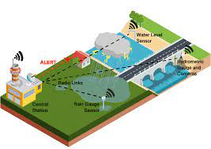

**4.3 Design and develop an early warning system using Web and SMS.**

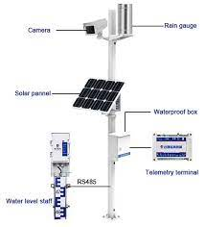

The researchers developed two different platforms in disseminating information to the concern

stakeholders for a possible flood event. One would be the real-time monitoring through a web-based

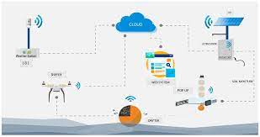

system that can be access through the Internet. Another one is the SMS notification system wherein an

automatic communication between the system and the local communities and other concern agencies in

the province of Isabela.

The web-based monitoring system was written in PHP programming language and used MySQL as

back-end to store information uploaded by the SMS notification system. The web-based monitoring

system also contains the different information for monitoring flood such as level of water, alert level,

flood warning status, affected areas and update logs. Also the web application automatically updated

when new information was uploaded

The developed SMS application acts as the brain of the entire system. It performs processing on data

sent by the water level monitoring system, responsible in uploading an update for the web-based

monitoring, sending notification to the concern stakeholders and reply on request for update through

keywords. The SMS application implement fuzzy logic algorithm in giving notifications. Based from

the alert level received that served as input, the application can provide a warning status as an output.

Also, the developed SMS application allows concern individuals to inquire about the current status

of a possible flood event. By sending a message containing the keywords “Flood Status”, the system

will send a reply message that contains the alert level, flood warning status and areas affected by flood.

By this feature it allows the system to perform two-way communication between the system and the

community in general.

**5. Conclusion**

The project contributes towards economy and the citizens. It envisions a safe, prepared and less casualty

community before, during and after typhoon devastation. The model also promotes the use of real-time

monitoring system through the developed web-based application and SMS notification system as an

easy medium in disseminating information particularly in the remote areas. By allowing the system in

two-way communication, it gives more flexibility in providing important information to the community.

Finally, the developed flood monitoring and early warning system that utilizes ultrasonic sensor to

detect water level, functions perfectly according to the specification provided. It successfully passed

several tests based on the different parameters.

**References**

[1] Pagatpat J C, Arellano A C and Gerasta J (Iligan City, Philippines: Mindanao-State University-

Iligan Institute of Technology).

[2] Vitales J S, Villajin L D, Destreza F G, Ricafranca D V, and Rodriguez V M R 2016 College of

Engineering and Computing Sciences (Batangas, Philippines: Batangas State University

ARASOF Nasugbu).

[3] dost.gov.ph 2016 Available:

http://dost.gov.ph/component/search/?searchword=flood%20monitoring%20with%20project

%20NOAH&searchphrase=all&Itemid=101.